U8 Install Word Press

After installing WordPress, I logged in and landed on the dashboard.

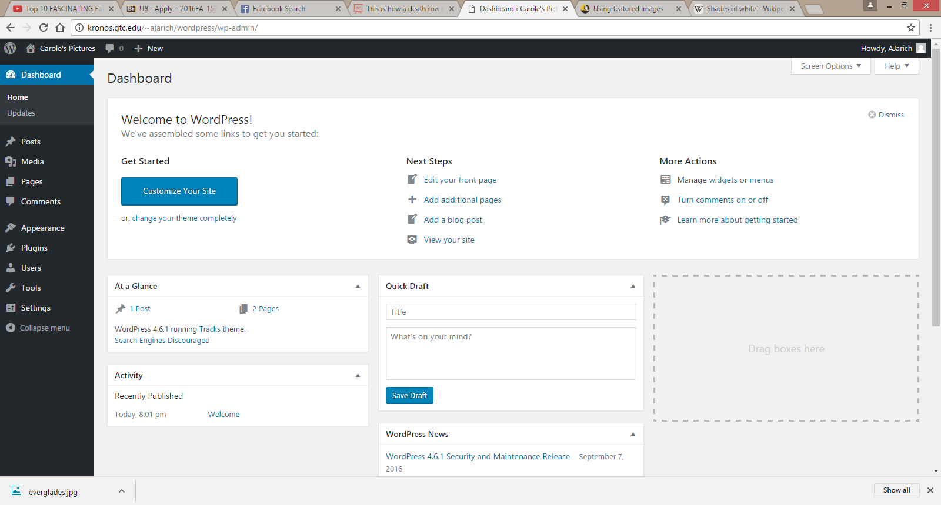

I then searched for a theme and selected the one I wanted. The one I chose was called Tracks.

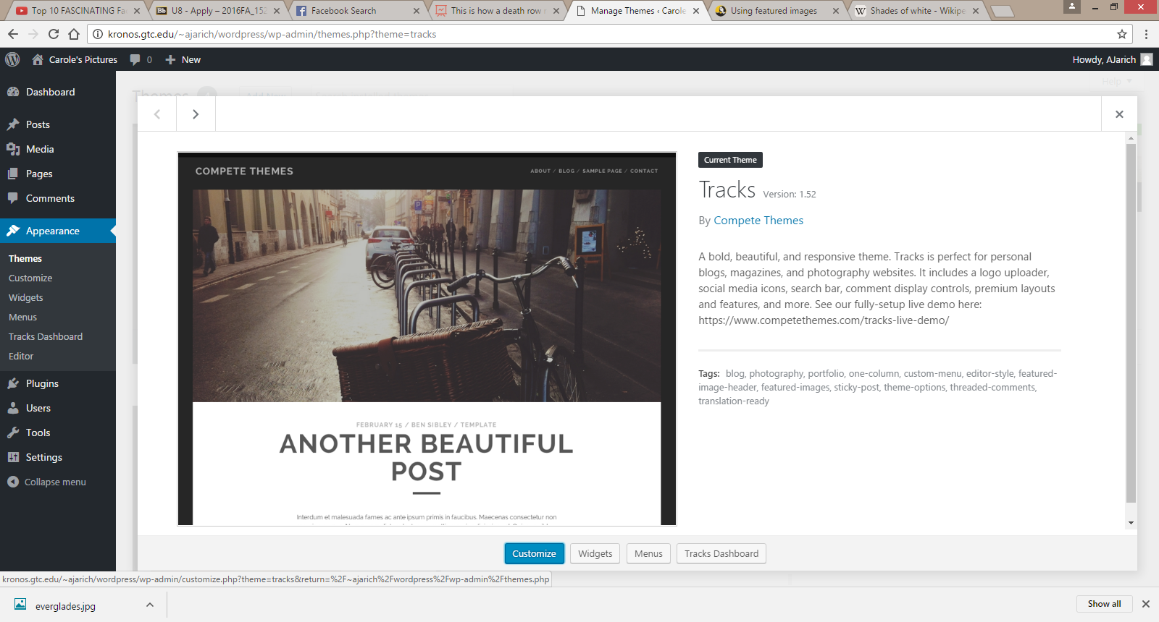

I began to work on two pages. The first one is the home page for the site. I not only added text to the body, but I also included a featured image. One other thing I did was put in some custom CSS. I made it so that the body was the color of White Smoke (#F5F5F5) and that the link at the bottom of the page in the footer area did not display.

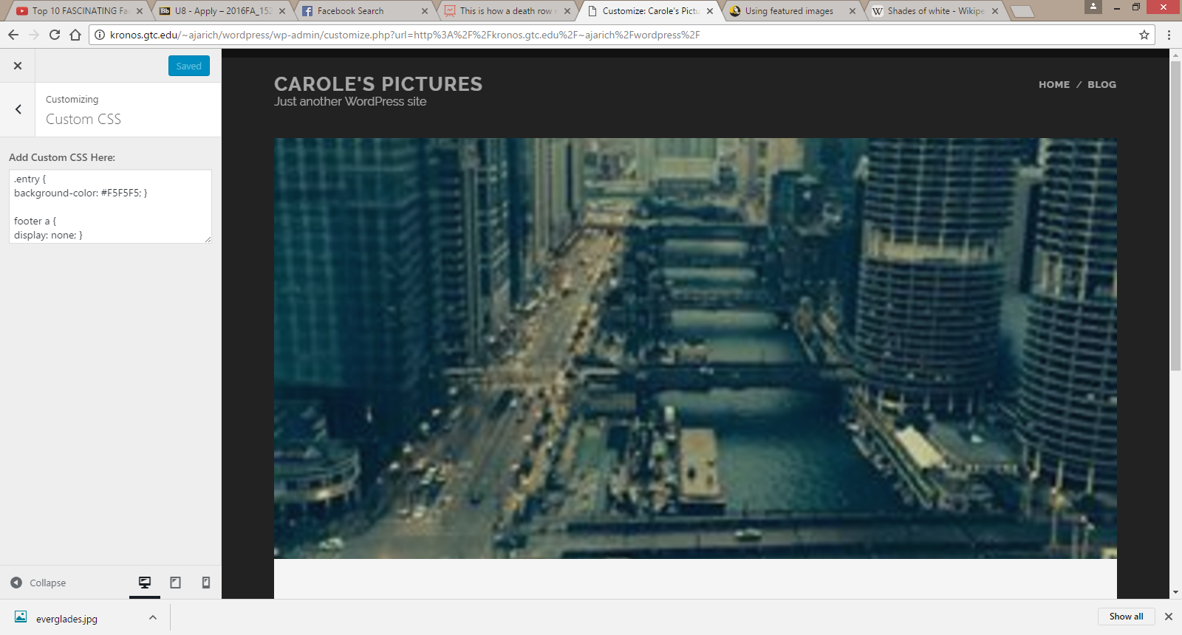

In the posts page, I wrote a basic post that said welcome to the site and what the blog will mainly be about. I got rid of meta widget that displayed in the After Post Content.

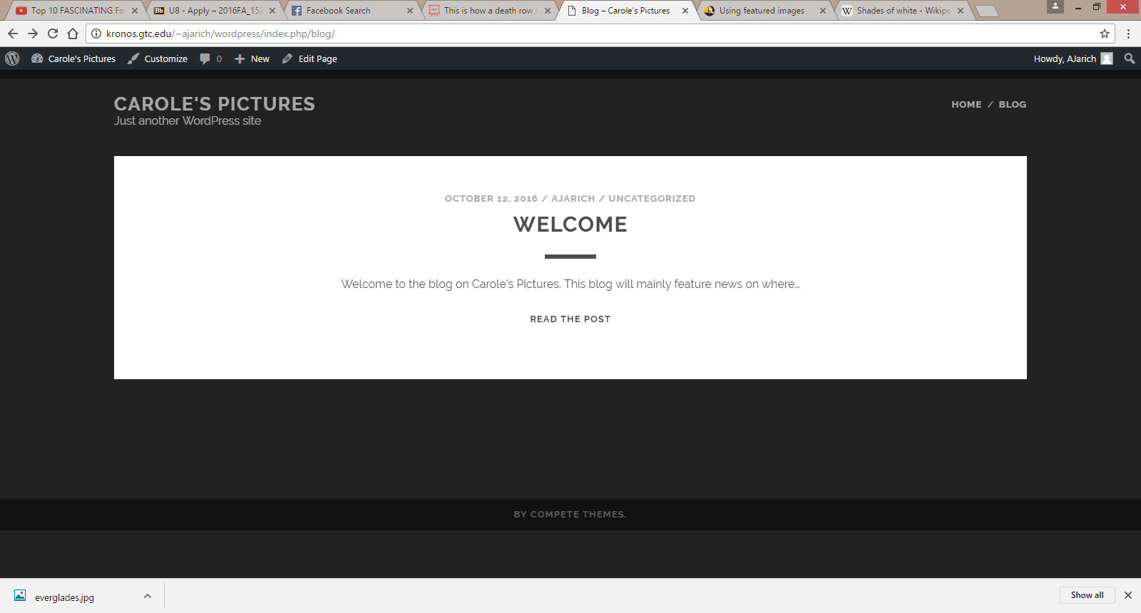

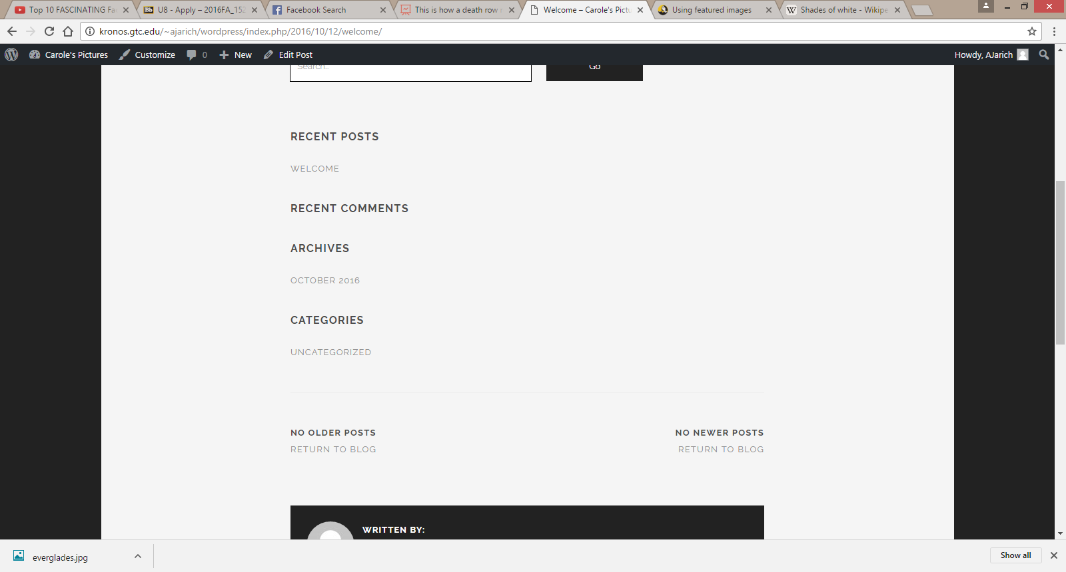

One last thing I did was edit the menu so that “Home” goes before “Blog”.

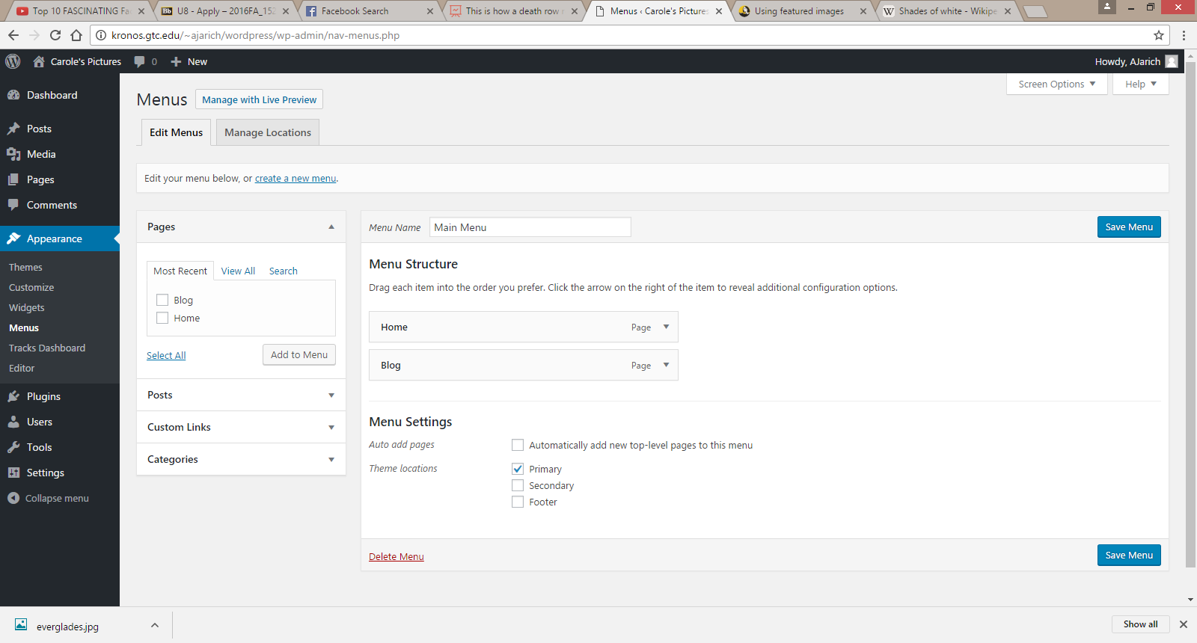

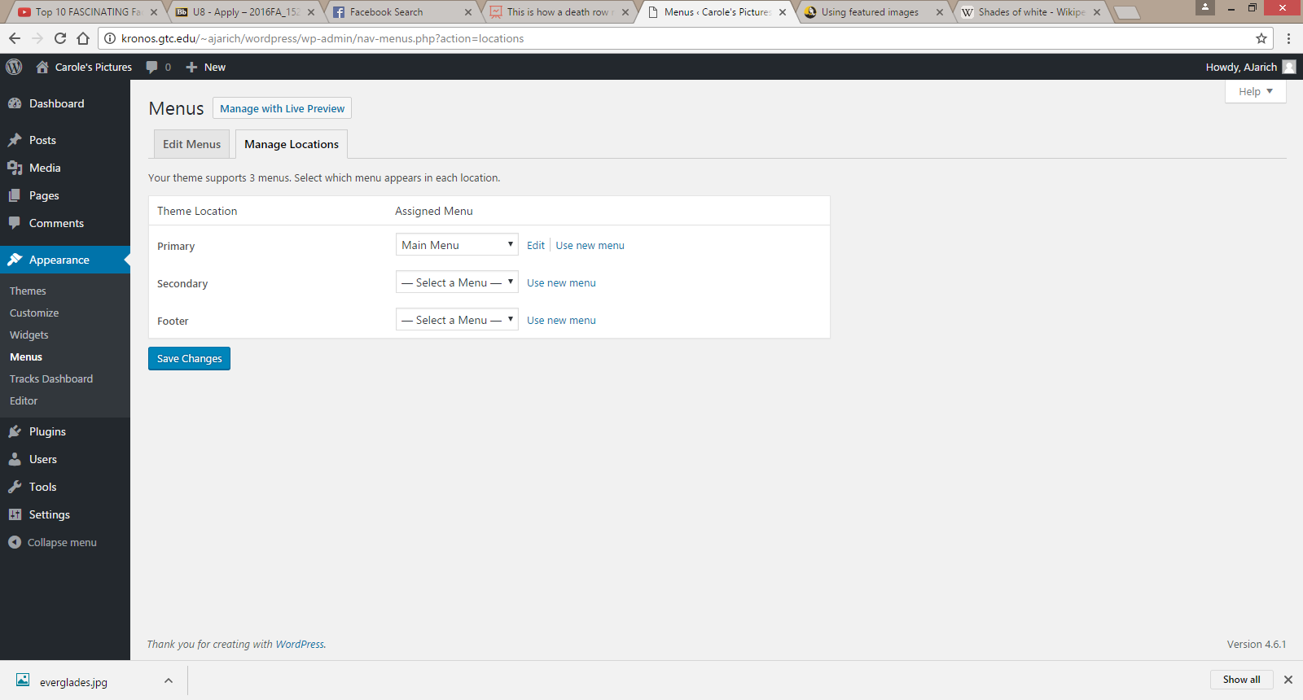

This was how the website turned out overall.

